# Lab: Lists Basics

Problems for in-class lab for the [Python Fundamentals Course @SoftUni](https://softuni.bg/trainings/3003/python-fundamentals-september-2020).   
Submit your solutions in the SoftUni judge system at <https://judge.softuni.bg/Contests/Practice/Index/1724>

## Strange Zoo

You are at the zoo and the **meerkats** look strange**.** You will receive **3 strings**: (tail, body, head). You have to **re-arrange** the elements in a list, so that the animal looks normal again: (head, body, tail)

### Example

|  |  |
| --- | --- |
| **Input** | **Output** |
| my tail  my body seems on place  my head is on the wrong end! | ['my head is on the wrong end!','my body seems on place','my tail'] |
| tail  body  head | ['head', 'body', 'tail'] |

### Hints

We start by reading the three parts of the body:

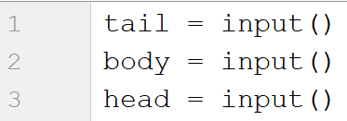

Then, we create a list containing those three:



We swap the elements and print the list



## Courses

You will receive a single number **n**. On the next **n** lines you will receive **names** of courses. You have to create a **list of them and print it**

### Example

|  |  |
| --- | --- |
| **Input** | **Output** |
| 2  PB Python  PF Python | ['PB Python', 'PF Python'] |
| 4  Front-End  C# Web  JS Core  Programming Fundamentals | ['Front-End', 'C# Web', 'JS Core', 'Programming Fundamentals'] |

### Hints

We read the number **n** and we create an **empty list**

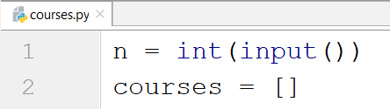

We create a loop, read each course and add it in the list

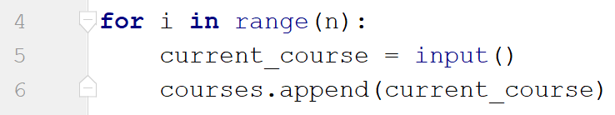

Finally, we print the list



## List Statistics

You will be given a number **n**. On the next **n** lines you will receive integers. You have to create and print two lists:

* One with all the positives (including 0) numbers
* One with all the negatives numbers

Finally print the following message**: "Count of positives: {count_positives}. Sum of negatives: {sum_of_negatives}"**

### Example

|  |  |
| --- | --- |
| **Input** | **Output** |
| 5  10  3  2  -15  -4 | [10, 3, 2]  [-15, -4]  Count of positives: 3. Sum of negatives: -19 |

### Hints

We start by reading the number n:

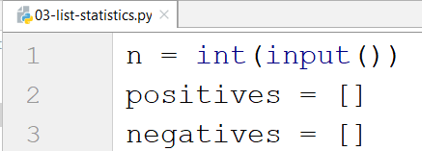

Then, we create **a loop**, we read the **current number** and check if it **is greater than zero or not**

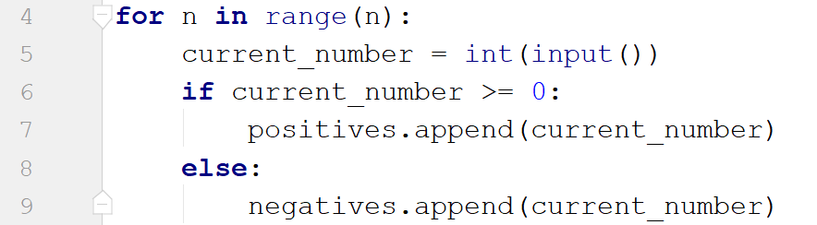

* If it is, we add it to the positives list
* If it is not, we add it to the negatives list

Then we print the three lines:



* To get the count of the positives we can use the **len** function
* To get the sum of the negatives we can use the **sum** function

## Search

You will receive a number **n** and a **word**. On the next **n lines** you will be given some **strings**. You have to **add** them in a **list and print** them. After that you have **to filter out** only the strings that **include** the given **word** and **print** that list too.

### Example

|  |  |
| --- | --- |
| **Input** | **Output** |
| 3  SoftUni  I study at SoftUni  I walk to work  I learn Python at SoftUni | ['I study at SoftUni', 'I walk to work', 'I learn Python at SoftUni']  ['I study at SoftUni', 'I learn Python at SoftUni'] |
| 4  tomatoes  I love tomatoes  I can eat tomatoes forever  I don't like apples  Yesterday I ate two tomatoes | ['I love tomatoes', 'I can eat tomatoes forever', "I don't like apples", 'Yesterday I ate two tomatoes']  ['I love tomatoes', 'I can eat tomatoes forever', 'Yesterday I ate two tomatoes'] |

### Hints

We start by reading the number n, the word we will search for and create our empty list

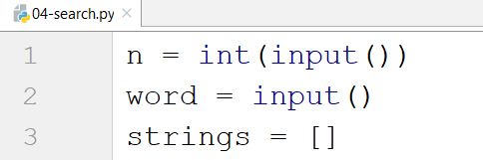

We create a loop and add all the strings in our list. After that, we print it

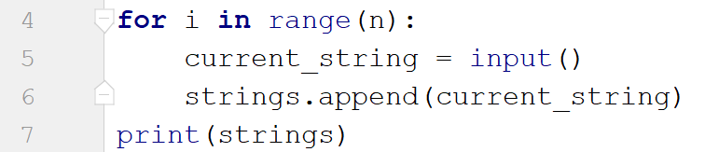

Finally, we create another loop to remove the strings we don't need by iterating through the strings reversed (so we don't skip elements by removing) and print the list again

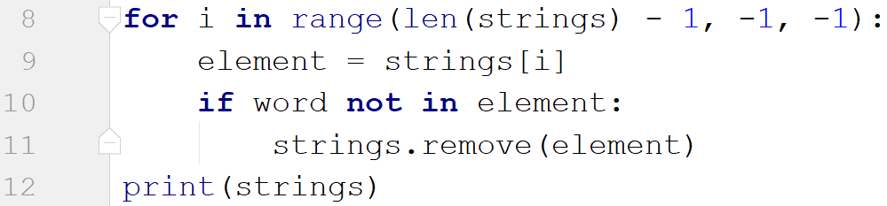

## Numbers Filter

You will receive a single number **n**. On the next **n** lines you will receive integers. After that you will be given one of the following commands:

* even
* odd
* negative
* positive

Filter all the numbers that fit in the category (0 counts as a positive and even). Finally, print the result.

### Example

|  |  |
| --- | --- |
| **Input** | **Output** |
| 5  33  19  -2  18  998  even | [-2, 18, 998] |
| 3  111  -4  0  negative | [-4] |

### Hints

First, we read the number n and we create the numbers list and the filtered list

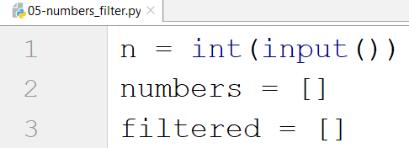

We create a loop to read all the numbers and to add them to the list

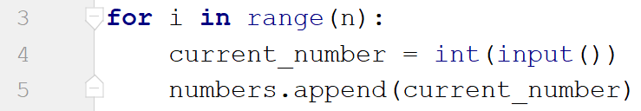

Then we read the command and check for all the cases

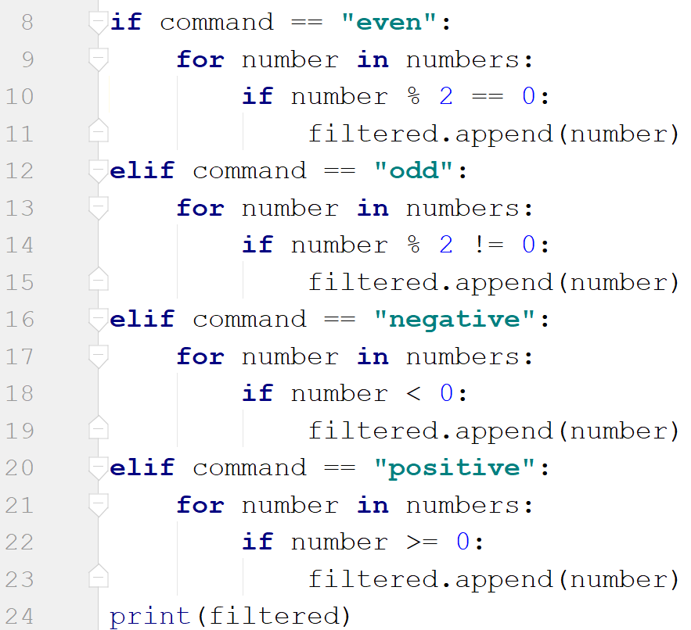

* Finally, we print the filtered list